**Lab: DOM Manipulations**

Problems for in-class lab for the [“JavaScript Advanced” course @ SoftUni](https://softuni.bg/courses/js-advanced). Submit your solutions in the SoftUni judge system at <https://judge.softuni.bg/Contests/1549/Lab-DOM-Manipulation>.

1. **List of Items**

Write a **function** that **reads** the **text**  inside an input field and **appends** the specified text to a list inside an HTML page.

Submit **only** the **addItem()** function in judge.

**Input/Output**

There will be no input/output, your program should instead **modify** the DOM of the given HTML document.

**Examples**

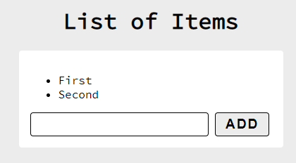 🡪 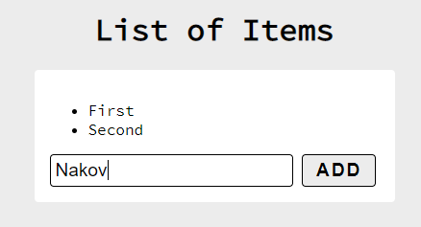 🡪 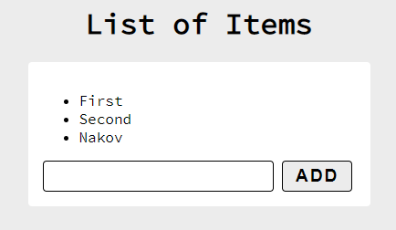

1. **Add / Delete**

Extend the previous problem to display a **[Delete] link** after each list item. **Clicking** it should **delete** the item with no confirmation.

Submit **only** the **addItem()** function in judge.

**Input/Output**

There will be no input/output, your program should instead **modify** the DOM of the given HTML document.

**Examples**

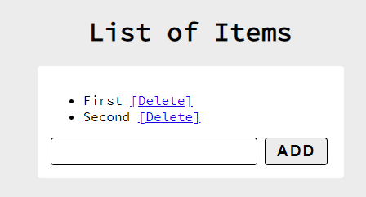 🡪 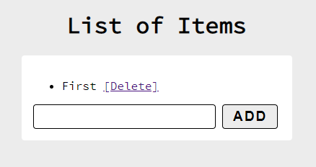

1. **Delete from Table**

Write a program that **takes** an **e-mail** from an **input field** and **deletes** the matching row from a table. If no entry is found, an **error** should be displayed in a **<div>** with ID "**results**". The error should be "**Not found**." Submit **only** the **deleteByEmail()** function in judge.

**Input/Output**

There will be no input/output, your program should instead **modify** the DOM of the given HTML document.

**Examples**

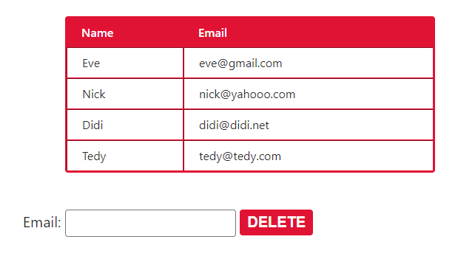

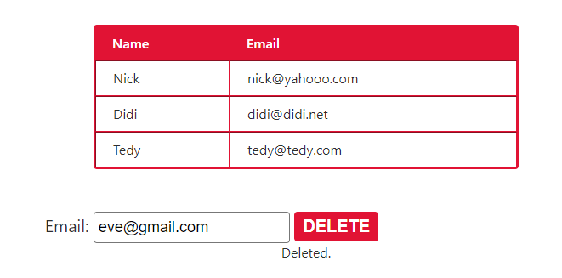

1. **Stopwatch**

Write a **timer** that counts **minutes** and **seconds**. The user should be able to control it with **buttons**. Clicking **[Start]** **starts** the **counter.** Clicking **[Stop]** **resets** the timer back to **zero**. Only **one** of the buttons should be **enabled** at a time (you cannot stop the timer, if it is not running).

Submit only the **stopwatch()** function in judge.

**Input/Output**

There will be no input/output, your program should instead **modify** the DOM of the given HTML document.

**Examples**

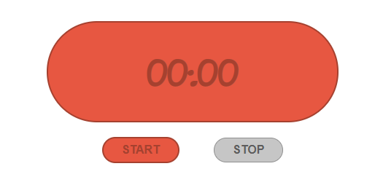

1. **Mouse Gradient**

Write a program that **detects** and **displays** how far along a gradient the user has **moved** their **mouse**. The result should be **rounded down** and displayed as a **percentage** inside the **<div>** with ID "**result**".

Submit **only** the **attachGradientEvents()** function in judge.

**Input/Output**

There will be no input/output, your program should instead **modify** the DOM of the given HTML document.

**Examples**

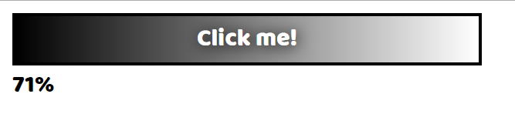

1. **Highlight Active**

Write a **function** that **highlights** the **currently active** section of a document. There will be **multiple** divs with **input fields** inside them. Set the **class** of the **div** that contains the **currently focused** input field to "**focus**". When focus is lost (**blurred**), **remove the class** from the element.

Submit only the **focus()** function in judge.

**Input/Output**

There will be no input/output, your program should instead **modify** the DOM of the given HTML document.

**Example**

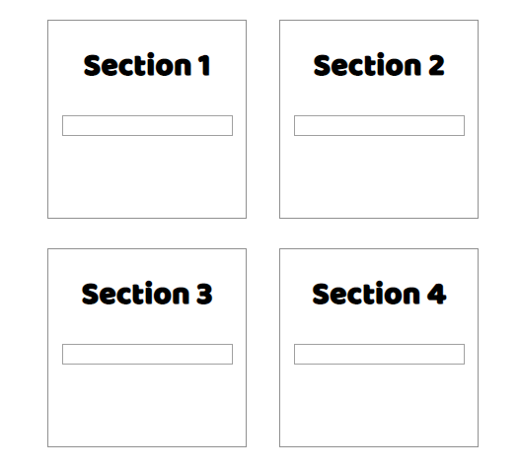 🡪 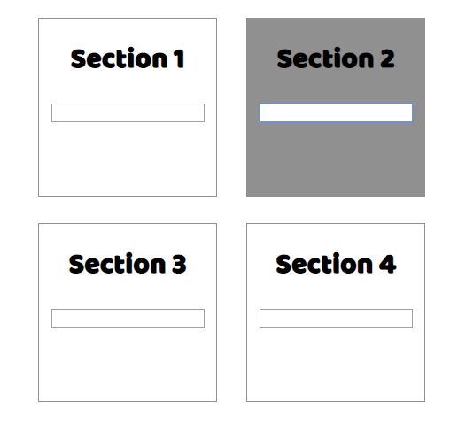

1. **Dynamic Validation**

Write a **function** that **dynamically validates** an **email** input field when it is **changed**. If the input is **invalid**, apply the style "**error**". Do **not** validate on every keystroke, as it is annoying for the user, consider only **change** events.

A valid email is considered to be in the format: **<name>@<domain>.<extension>**

Only **lowercase Latin characters** are allowed for any of the parts of the email. If the input is valid, **clear** the style. Submit **only** the **validate()** function in judge.

**Input/Output**

There will be no input/output, your program should instead **modify** the DOM of the given HTML document.

**Example**

 